

Activity Manual- Register and Promote Model Versions

Prepared for:

Date: 18th Nov 2025

Prepared by:
Document Name: Lab Manual Document Number MLOps
Contributor:

Contents
1. Lab Objective 3
2. Lab Architecture 3
3. Step 1 – Verify Project Structure 3
4. Step 1B – Billing_data.csv 4
5. Step 1B – Create Feature 4
6. Step 2 –train_model.py 5
7. Step 3 – Execute the Training Program 6
8. Step 4 – Verify the Model 7
9. Step 5 – Start MLflow 7
10. Step 6 – Create register_model.py 8
11. Step 7 – Execute register_model.py 8
12. Step 8 – Open MLflow Model Registry 9
13. Step 9 – Promote to Staging 9
14. Step 10 – Promote to Production 10
15. Step 11 – Create a New Version 10
16. Step 12 – Promote Version 2 10
17. Lab Summary 11

Lab Objective
In this lab, you will learn how to:
- Train an AI model
- Save the trained model
- Register the model in MLflow
- Create model versions
- Promote the model to Staging
- Promote the model to Production

Lab Architecture
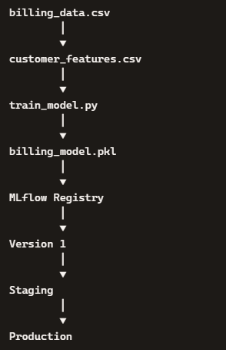

Step 1 – Verify Project Structure
Description Before training the AI model, verify that the project structure is correct.
Folder Structure
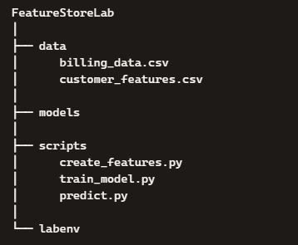

Tester Activity Verify: ✔ customer_features.csv exists ✔ models folder exists

Step 1B – Billing_data.csv

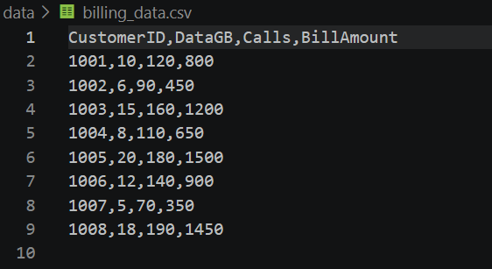

Step 1B – Create Feature
create_features.py
# Import the Pandas library
import pandas as pd

# Read the Vodafone billing dataset
df = pd.read_csv("../data/billing_data.csv")

# Create business features

# Feature 1: Monthly Data Usage
df["MonthlyDataUsage"] = df["DataGB"]

# Feature 2: Average Call Count
df["AverageCallCount"] = df["Calls"]

# Feature 3: Monthly Bill
df["MonthlyBill"] = df["BillAmount"]

# Feature 4: Usage Billing Ratio
df["UsageBillingRatio"] = df["DataGB"] / df["BillAmount"]

# Save the generated features
df.to_csv("../data/customer_features.csv", index=False)

print("Feature Store Created Successfully")

print(df)

Step 2 –train_model.py
Description This program reads the Feature Store, trains the AI model, and saves the trained model into the models folder.
Location scripts/train_model.py
import pandas as pd
import joblib
from pathlib import Path
from sklearn.tree import DecisionTreeClassifier
import mlflow
import mlflow.sklearn

print("Training AI Model...")

# -------------------------------------------------------
# Read Feature Store
# -------------------------------------------------------
df = pd.read_csv("../data/customer_features.csv")

# -------------------------------------------------------
# Create Target Column
# 0 = Normal Billing
# 1 = Billing Anomaly
# -------------------------------------------------------
df["BillingStatus"] = [0, 0, 1, 0, 1, 0, 0, 1]

# -------------------------------------------------------
# Select Features
# -------------------------------------------------------
X = df[["MonthlyDataUsage", "AverageCallCount", "MonthlyBill", "UsageBillingRatio"]]
y = df["BillingStatus"]

# -------------------------------------------------------
# Train Model
# -------------------------------------------------------
model = DecisionTreeClassifier()
model.fit(X, y)

print("AI Model Trained Successfully")

# -------------------------------------------------------
# Save Model Locally
# -------------------------------------------------------
BASE = Path(__file__).resolve().parent.parent
model_folder = BASE / "models"
model_folder.mkdir(exist_ok=True)

joblib.dump(model, model_folder / "billing_model.pkl")

print("Model saved successfully")
print("Location :", model_folder / "billing_model.pkl")

# -------------------------------------------------------
# Log and Register Model in MLflow
# -------------------------------------------------------
mlflow.set_experiment("VodafoneBillingAI")

with mlflow.start_run():
# Log parameters and metrics
mlflow.log_param("model_type", "DecisionTreeClassifier")
mlflow.log_metric("training_accuracy", model.score(X, y))

# Log and register model
mlflow.sklearn.log_model(
model,
artifact_path="billing_model",
registered_model_name="RegressionModel"
)

print("Model logged and registered in MLflow")

Step 3 – Execute the Training Program
Description Run the training program to build the AI model.
Commands
cd scripts
python train_model.py
Expected Output
AI Model Trained Successfully
Model saved successfully

Location : ...\models\billing_model.pkl

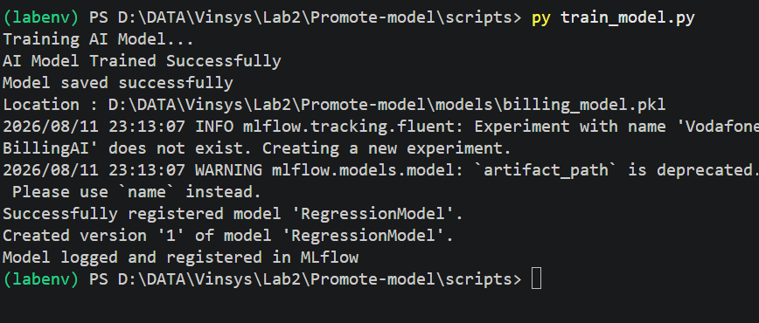
Tester Activity ✔ Training completed ✔ No errors PASS

Step 4 – Verify the Model
Description Open the models folder.
Expected billing_model.pkl exists.
Tester Question Was the model created? Expected Answer: YES

Step 5 – Start MLflow
Description Start the MLflow Tracking Server.
Commands
mlflow ui
Browser http://localhost:5000
Expected MLflow Dashboard opens.

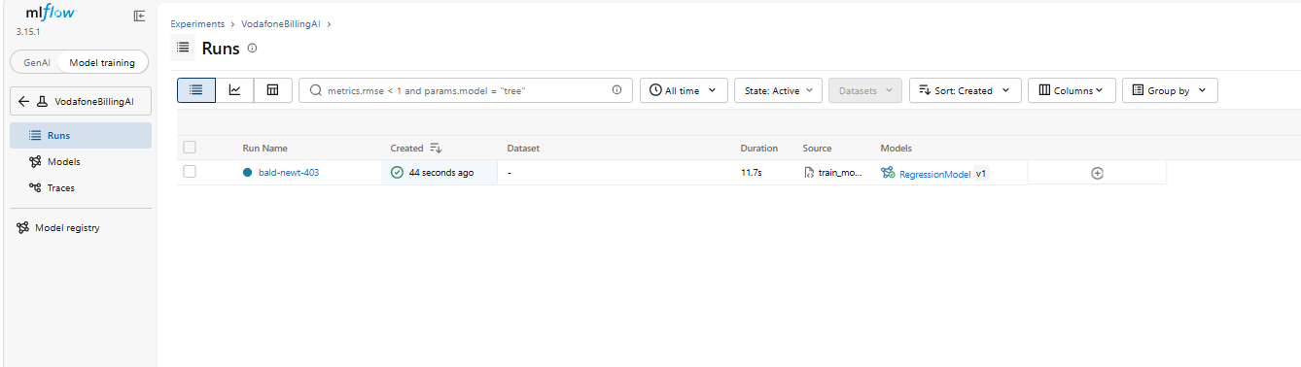
Tester Activity ✔ MLflow UI opened PASS

Step 6 – Create register_model.py
Description Registers the trained model in MLflow Model Registry.
Location scripts/register_model.py
import mlflow

model_name = "RegressionModel"

print("Registering Model...")
print("Model Name :", model_name)
print("Version 1 Created")

# Instructor Note:
# In real workflows, registration is done via MLflow APIs after logging the model.

Step 7 – Execute register_model.py
Commands
cd scripts
python register_model.py
Expected Model registered as RegressionModel, Version 1.
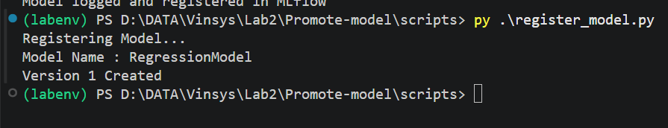

Step 8 – Open MLflow Model Registry
Browser http://localhost:5000 → Models
Expected RegressionModel → Version 1
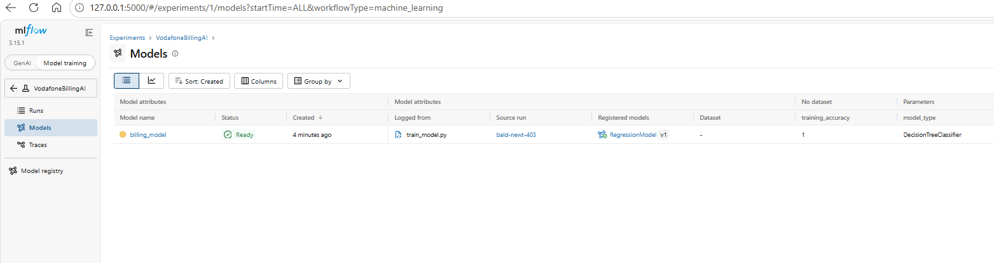
Tester Activity ✔ Model exists ✔ Version 1 created PASS

Step 9 – Promote to Staging
Description QA team validates the model before deployment.
Action MLflow → RegressionModel → Version 1 → Transition Stage → Staging
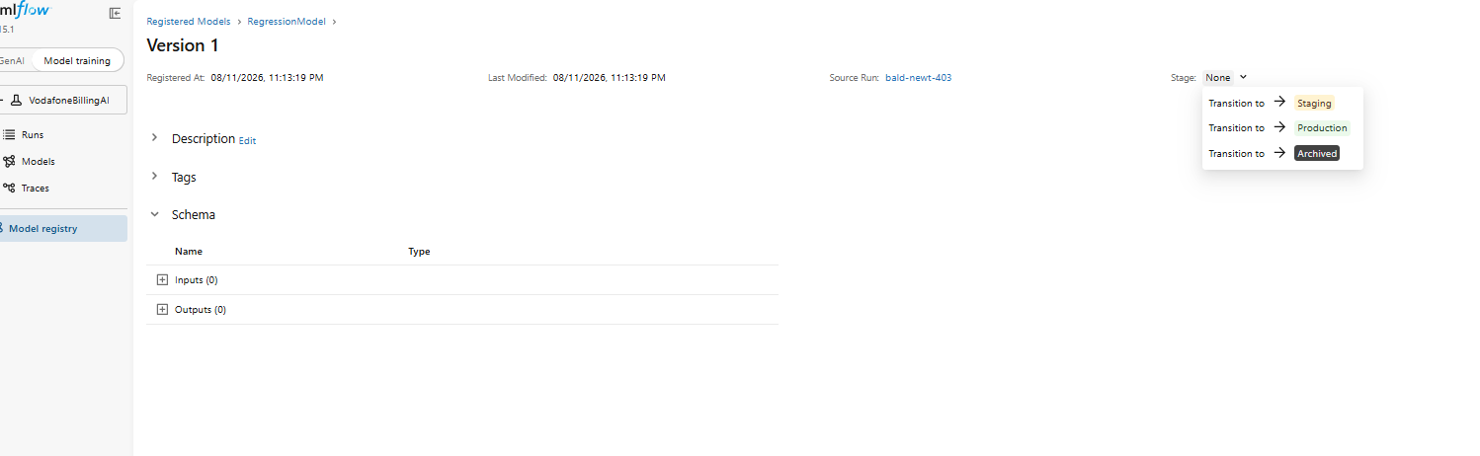
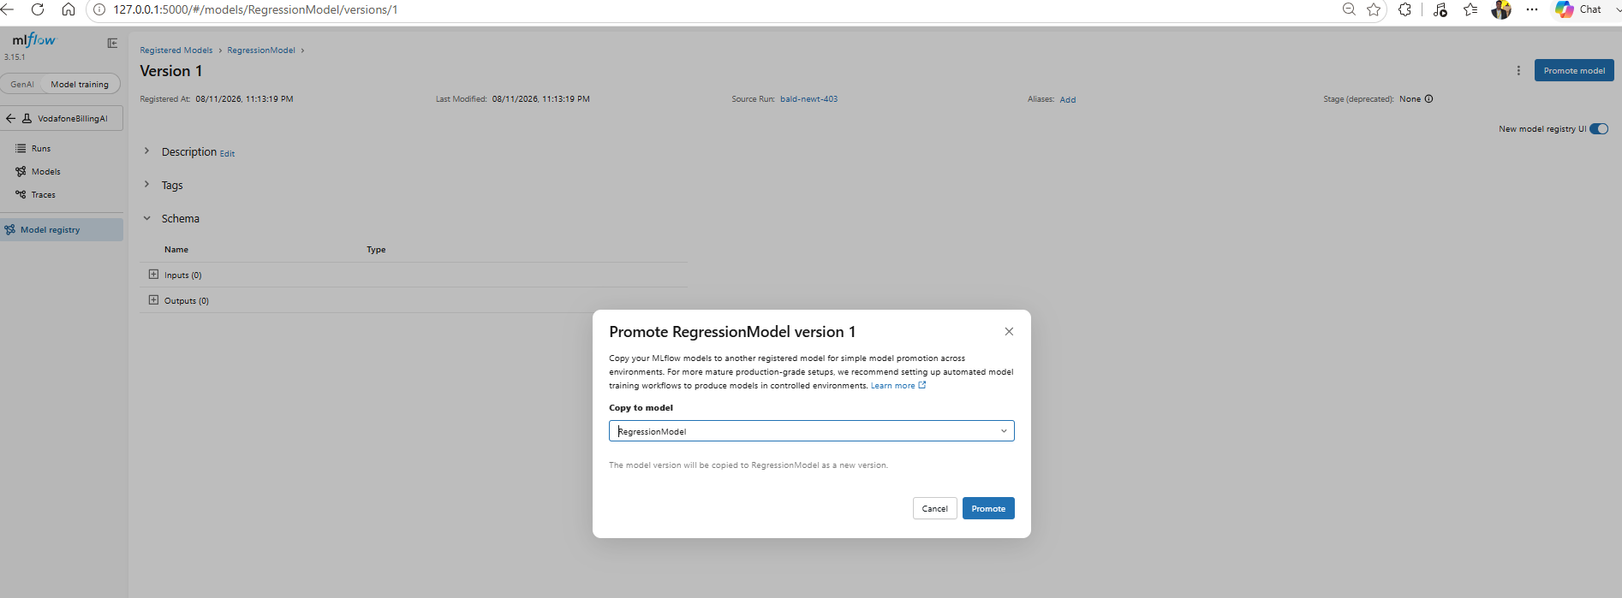
Expected Stage = Staging
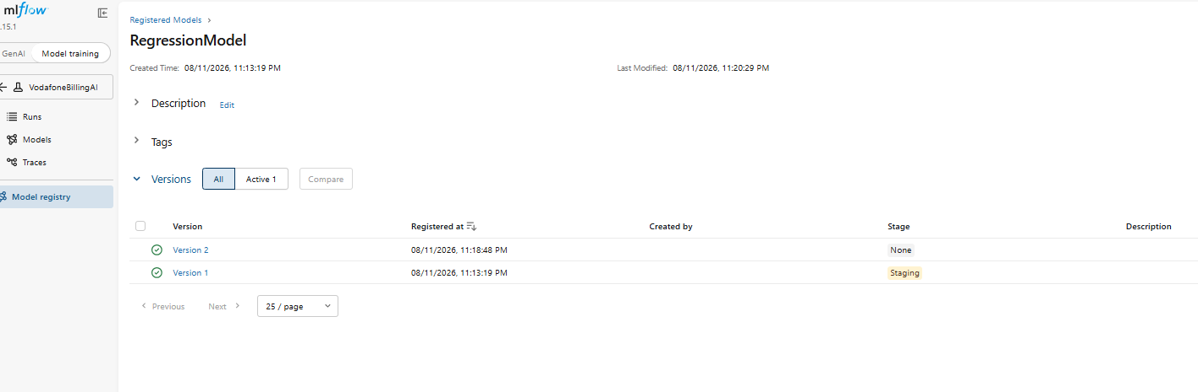
Tester Activity ✔ Version promoted PASS

Step 10 – Promote to Production
Description After validation, promote to Production.
Expected Stage = Production, Version 1
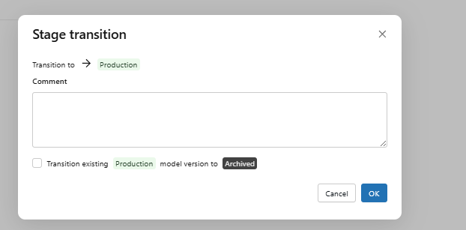
Tester Activity ✔ Only approved model is in Production PASS

Step 11 – Create a New Version
Description Modify billing_data.csv, regenerate features, retrain model, and register again.
Expected RegressionModel → Version 2
Tester Activity ✔ Version 2 created PASS

Step 12 – Promote Version 2
Description Promote Version 2 to Production.
Expected
- Production = Version 2
- Version 1 archived
Tester Activity ✔ Version 2 promoted to Production ✔ Version 1 archived ✔ Only one Production version active

Lab Summary
In this lab, you learned how to:
- Train and save an AI model
- Store the trained model in the models folder
- Register models in MLflow Model Registry
- Create model versions
- Promote models through Staging and Production
- Verify model promotions from a QA/Test Engineer’s perspective

